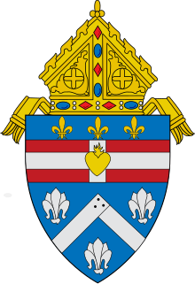
Form Requesting Deputation for Extraordinary Ministers of Holy Communion
(TO BE SUBMITTED TO THE OFFICE OF CANONIAL AFFAIRS)
DIOCESE OF HOUMA-THIBODAUX

Name of person submitting form _______________________________________________________
Email Address ____________________________________ Phone #__________________________
Name of Institution (Church Parish or School) ___________________________________________
Position at institution _________________________________________________________________
Date of submission of this form_________________________________________________________

Dear Very Reverend Eric P. Leyble, JCL,
I certify that the people whose names are listed below have completed the training program for Extraordinary Ministers of Holy Communion required by the Diocese of Houma-Thibodaux.
Therefore, I request that on behalf of the Office of the Bishop, you depute them for initial, or ongoing service, as an Extraordinary Minister of Holy Communion for which expires on December 31, 2029, and for the institution indicated above.

___________________________________
Pastor’s Signature

NB: Parish deputation does not apply to Diocesan Catholic High Schools. The Diocesan Catholic High Schools must submit their own lists to be granted deputation for that location.
Name | Institution Name  Church/School | PLEASE CHECK ALL THAT APPLY
Name | Institution Name  Church/School | Service at  Mass | Communion to Sick  (Homebound,  Nursing Home,  Assisted Living) | Communion  at Catholic School
Name | Institution Name  Church/School | Service at  Mass | Communion to Sick  (Homebound,  Nursing Home,  Assisted Living | Communion  at Catholic School

